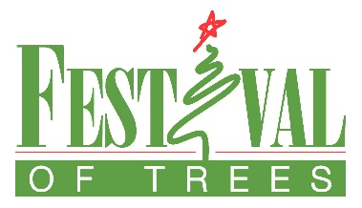
2021 Festival of Trees Gingerbread Village

To: Friends of the Festival
From: Cassie Keister, Cindy Parr-Barrett
Co-Chairs, Gingerbread Village
Re: Festival of Trees, Gingerbread Village

You’re invited to a house-raising, to a barn-raising, to build a church, or to build a school! Use your imagination and create a display for our Gingerbread Village!

Sounds like a lot of work? It’s not! As a matter of fact, it’s not only fun, but also tasty! We’re talking about this year’s edition of the Gingerbread Village at Festival of Trees.

The Gingerbread Village is a popular and exciting part of the Festival and we need your help to continue the tradition. Your creation will become a part of the village to be auctioned off, with proceeds benefiting the community projects of Balloons Over Vermilion. They can be the tasty creations of an individual, or a labor of love by a school, church group, civic organization, family, professional baker, or just good friends. This year’s theme is A Season of Hope. To show our appreciation, everyone who participates will receive a pair of general admission tickets to the Festival Saturday, November 13th through Wednesday November 17th.

If you wish to participate, please complete the enclosed entry form and return it to the Festival of Trees office by October 25th. Mail to Festival of Trees Danville, 112 N. Vermilion St. Danville, IL or email keister5@comcast.net

Please deliver your completed gingerbread creation to the David S. Palmer Arena on Wednesday, November 10th, between 8:00 a.m. and 6:00 p.m.

Contact Co-Chair Cassie Keister at 474-7770 or keister5@comcast.net or the Festival of Trees Office at 217-260-6716 or festivaloftreesdanville@gmail.com with questions or if you need more information.

Thank you for your consideration and see you at the Festival!
112 N. Vermilion St. Danville, IL 61832 – 217-260-6716 – festivaloftreesdanville@gmail.com

